

Project-Report

Python-Programming

Submitted to

Ms. Gurpreet kaur

Submitted by

Name: Pratyush Kashyap
UID: 25MCA20228
Section/Group: MCA-4-B

MASTER OF COMPUTER APPLICATION

Employee Payroll System

Acknowledgement

I would like to express my sincere gratitude to my faculty and project guide for their

continuous support, guidance, and motivation during the development of this project.

Their valuable suggestions and feedback have been instrumental in enhancing my

understanding of Python programming and software development.

I am also thankful to my friends and classmates for their encouragement and

cooperation throughout the project. Finally, I extend heartfelt thanks to my family for

their constant moral support and inspiration, without which this project would not have

been possible.

This project has given me practical exposure to applying theoretical knowledge in real-

world problem solving and has improved my technical, analytical, and logical skills.

Abstract

The Employee Payroll Management System is a desktop-based application developed

using Python’s Tkinter library for GUI and the CSV file format for data storage.

The main aim of the project is to simplify payroll management processes by allowing

easy addition, viewing, and salary calculation for employees in a user-friendly

interface.

This system helps HR departments or small businesses efficiently calculate salaries,

store employee data, and manage payrolls without the need for complex databases.

It automatically computes allowances like HRA (House Rent Allowance), DA

(Dearness Allowance), and deductions like Tax, generating the net salary instantly.

The application is lightweight, runs offline, and provides an intuitive graphical

interface, making it ideal for academic, training, or small-scale business use.

Keywords: Payroll System, Tkinter, CSV, Salary Management, Python GUI

Introduction

Employee payroll management is one of the most critical operations in any

organization. Manual payroll systems often lead to errors, delays, and inefficiencies in

calculating and recording employee salaries.

This project introduces an automated Employee Payroll Management System,

designed using Python.

The system features a Tkinter-based GUI that allows users to input employee details

such as name, designation, and basic salary. It then automatically calculates allowances

and net salary.

Unlike traditional systems that use large databases, this project uses CSV file storage,

making it simple to implement, portable, and easy to use even without an internet

connection.

Objectives

The key objectives of this project are:
- To develop an efficient payroll system using Python.
- To design a user-friendly graphical interface for easy operation.
- To automate the salary calculation process using formula-based computation.
- To store and retrieve employee data using CSV files.
- To minimize manual errors and improve record accuracy.
- To demonstrate the use of Tkinter for GUI design and data handling.

System Requirements

Hardware Requirements:
- Processor: Intel i3 or higher
- RAM: Minimum 4 GB
- Hard Disk: 250 MB free space
- Display: Standard 1366×768 resolution or higher

Software Requirements:
- Operating System: Windows 10 or 11
- Programming Language: Python 3.8+
- Libraries Used:
  - tkinter (GUI design)
  - csv, os (file handling)
  - ttk, messagebox (widgets and dialogs)
- Editor: Visual Studio Code or PyCharm

Database Design (CSV File Structure)

Since this system works offline, it uses a CSV (Comma Separated Values) file to store data instead of a MySQL database.

Column Name | Description
ID | Auto-generated employee number
Name | Employee’s full name
Designation | Job title or position
Basic Salary | User input for base salary
HRA | 20% of basic salary
DA | 10% of basic salary
Tax | 5% of basic salary
Net Salary | Computed final salary

Example Data:

ID | Name | Designation | Basic | HRA | DA | Tax | Net Salary
1 | Amit | Developer | 40000 | 8000 | 4000 | 2000 | 46000
2 | Priya | Manager | 50000 | 10000 | 5000 | 2500 | 62500

Implementation

The project is implemented in the following modules:

- GUI Design:
The Tkinter framework is used to create a clean and interactive window. It contains input boxes, buttons, and a data table.

- Data Entry Module:
Allows users to add employee details (name, designation, and basic salary).

- Salary Calculation Module:
Uses the formula:

- Net Salary = Basic + (0.2 × Basic) + (0.1 × Basic) − (0.05 × Basic)

- Data Storage Module:
Saves each record to employees.csv ensuring data persistence even after the program is closed.

- Data Display Module:
Displays all employee records in a table using ttk.Treeview.

- Error Handling:
Built-in message boxes handle invalid inputs and missing files gracefully.

Output:

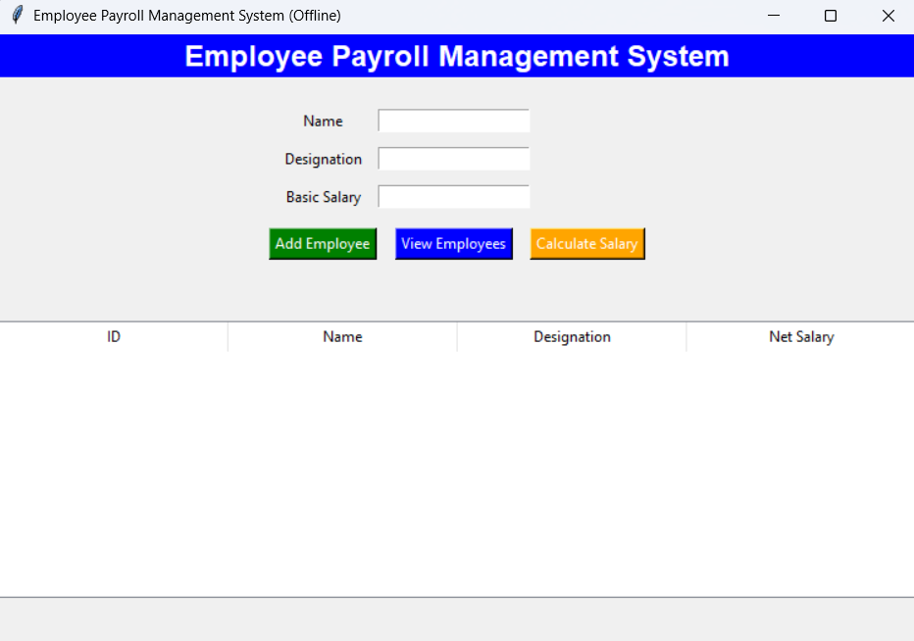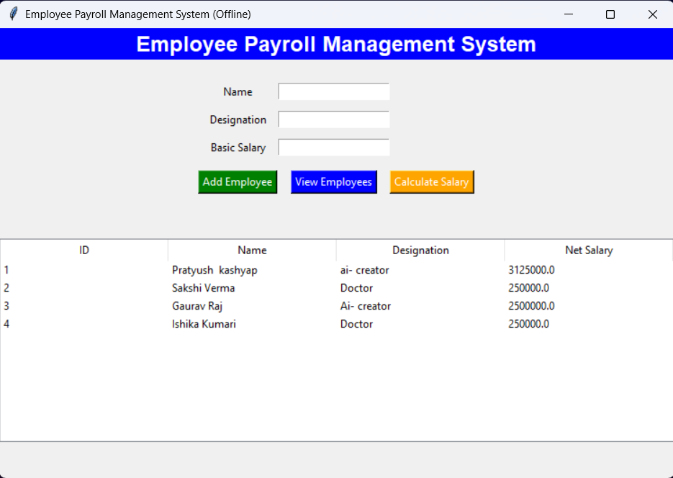

Conclusion

The Employee Payroll Management System provides an easy and efficient way to handle payroll operations.
It eliminates the need for manual salary calculations, ensures data accuracy, and saves time.
By using Python Tkinter and CSV, this project demonstrates how simple technologies can solve real-world problems effectively.
The application can be used by small organizations, schools, or businesses to maintain payroll records efficiently.

Future Enhancements
- Add employee search and filter features.
- Integrate data visualization using Matplotlib (bar or pie charts).
- Add a print option for generating salary slips.
- Implement user login and authentication.
- Extend database storage from CSV to MySQL for large organizations.
- Convert to a web-based payroll system using Flask or Django.

References
- Python Software Foundation, Python 3 Documentation – https://docs.python.org/3/
- Tkinter Official Documentation – https://docs.python.org/3/library/tkinter.html
- W3Schools Python Tutorial – https://www.w3schools.com/python/
- GeeksforGeeks Python Tkinter Tutorials – https://www.geeksforgeeks.org/python-tkinter/
- TutorialsPoint Python Programming – https://www.tutorialspoint.com/python/

GitHub Repository Link: https://github.com/kashyappratyush69-oss/Employee-Payroll-_System

